Computer Fundamentals

1. Objective of the Module
Understanding the physical components of a computer is essential because all digital attacks rely on hardware. Analysts need to know about RAM, CPU, and storage to understand how malware operates, how resources are exploited, and how to detect unusual system behavior.

2. 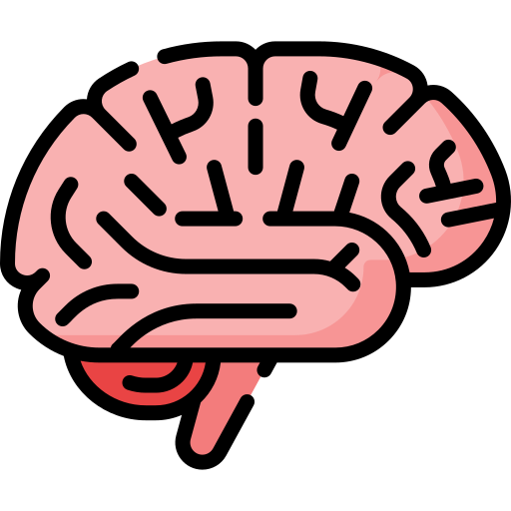 Key Concepts learned
- Inside a Computer & Types: Computers are made up of the motherboard, RAM (short-term memory), CPU (the brains of the system), HDD & SSD (long-term memory), PSU (power supply), and GPU (image processing). There are many different types of computers and each is good for specific jobs; for example, a laptop is a portable everyday computer whereas workstations are high-performance, accurate, and dependable for demanding professional applications.
- Client-Server Basics: A client is someone who initiates a request and a server is the system that serves it.
- Virtualization & Cloud Computing: Virtualization lets one physical computer create multiple independent environments using a hypervisor, which divides hardware like CPU, memory, and storage into separate virtual machines, each running its own operating system. Cloud computing uses virtualization to turn physical hardware into flexible, software-controlled resources. It allows businesses to quickly set up, monitor, and scale their computing and storage needs without purchasing physical servers.

3. Business Relevance
Modern companies use virtual machines and cloud services mainly to save costs, increase flexibility, and improve reliability. Instead of purchasing physical computers, they use virtualization to divide a powerful server into multiple digital ones, reducing hardware waste and allowing quick scaling and easier backups. If a server goes offline or is attacked, a business stops working, affecting critical assets like databases and websites. This can cause big financial loss, data leaks, and severe damage to the company's reputation.

4. Summary & Reflections
This module was very helpful, but it also made me cautious about the move to cloud computing. Giving control of data to a third party creates new security risks. Plus, cloud infrastructure needs a lot of land and water to keep data centers running and cool, which raises serious environmental concerns.

